ROBOTICS & ARTIFICIAL INTELLIGENCE DEPARTMENT


Total Marks: Obtained Marks:
SZABIST
University

Computing Vision
Lab Task # 13

Submitted To: Mr. Muhammad Azhar

Student Name: Ejaz-us-Saboor

Reg. Number: 23108203

CV BS(AI)-6A SZABIST-ISB

Code Example 1: Customer Segmentation Using K-Means Clustering
ShopEase is a growing e-commerce platform that wants to personalize its marketing campaigns. The business team suspects that customers fall into natural segments based on spending behavior and visit frequency. However, these segments are not explicitly labeled in the data.
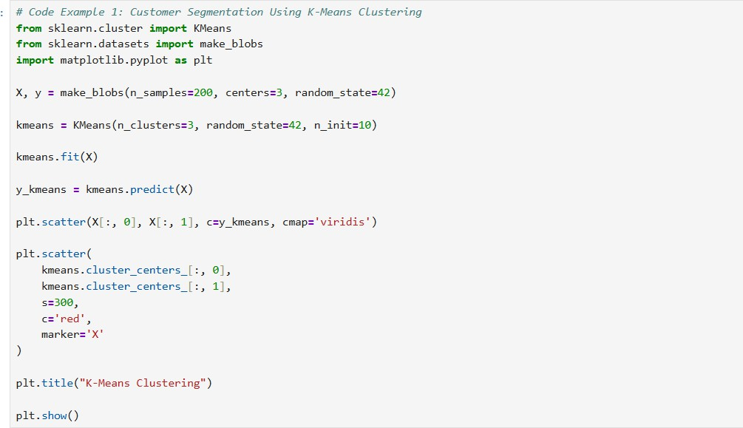
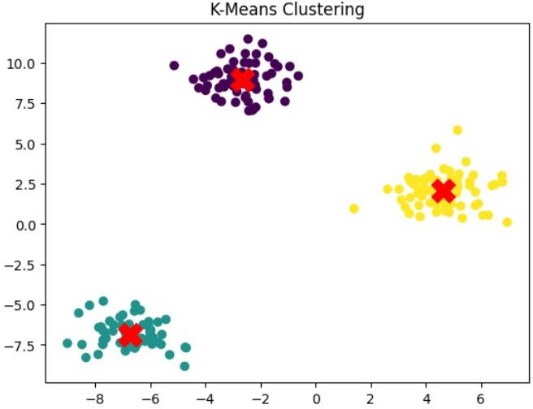
To uncover these hidden groups, the data science team applies K-Means clustering to identify customer segments based on purchasing patterns.

Code Example 2: Dimensionality Reduction for Customer Segmentation Visualization using Principal Component Analysis (PCA)
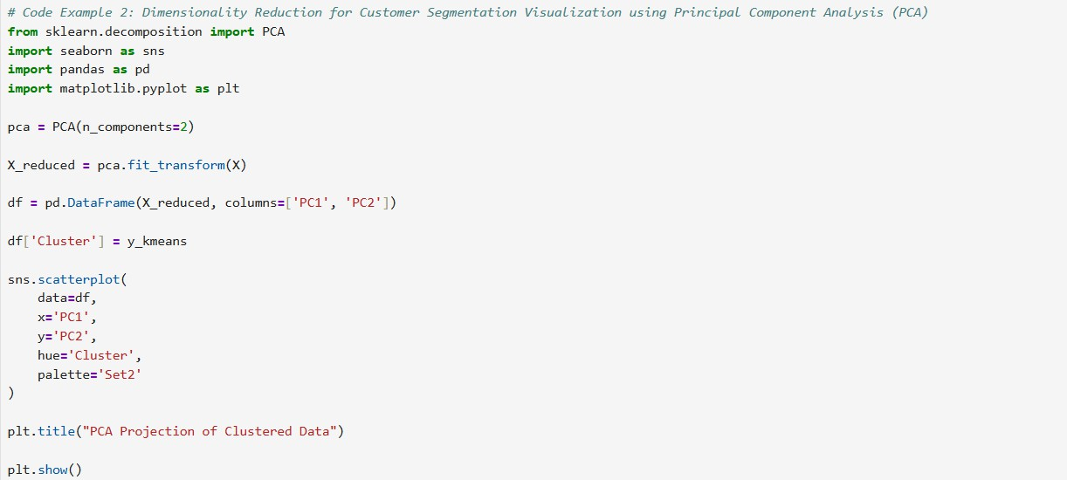
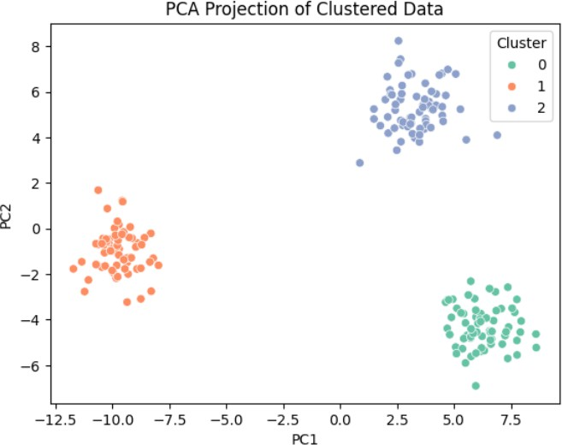

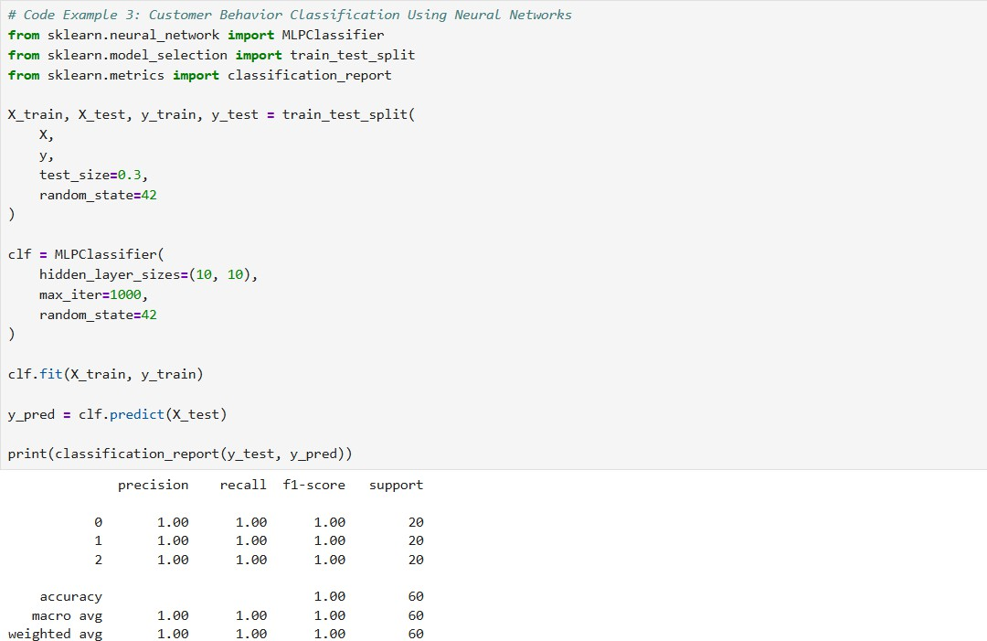
Code Example 3: Customer Behavior Classification Using Neural Networks

Case Study 1: Customer Segmentation in Marketing
A retail company wants to improve its targeted advertising. Instead of treating all customers the same, the marketing team wants to group customers based on behavior—such as average spending, frequency of purchase, and product categories.
To achieve this, the data team uses K-Means clustering to segment customers into groups with similar characteristics.
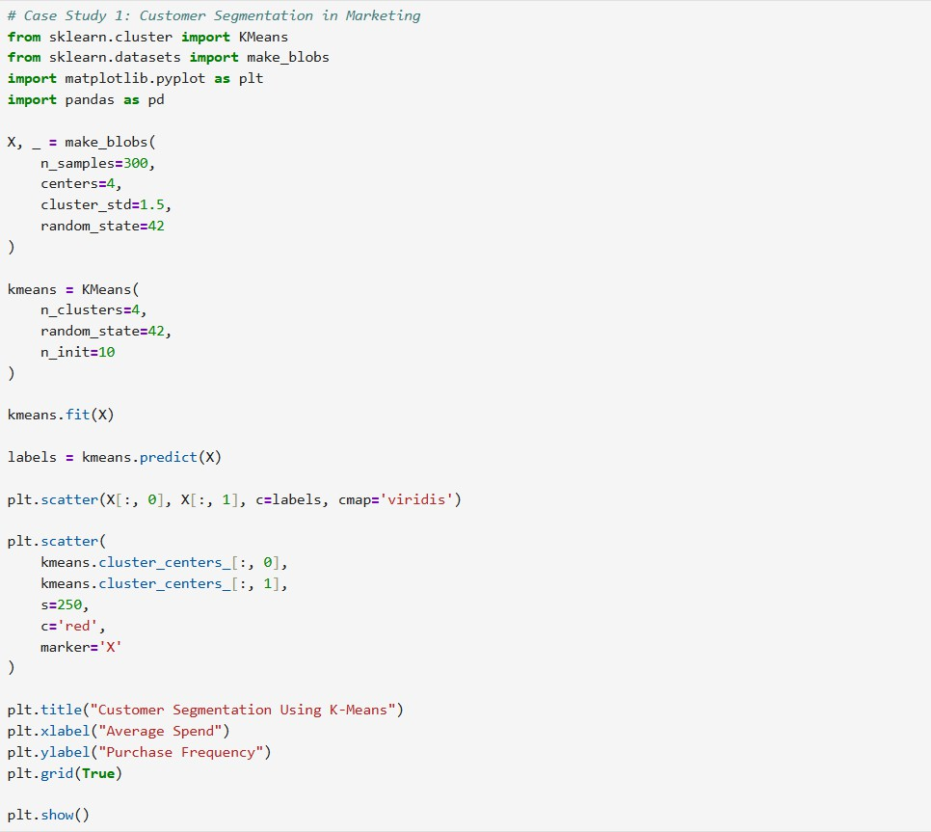

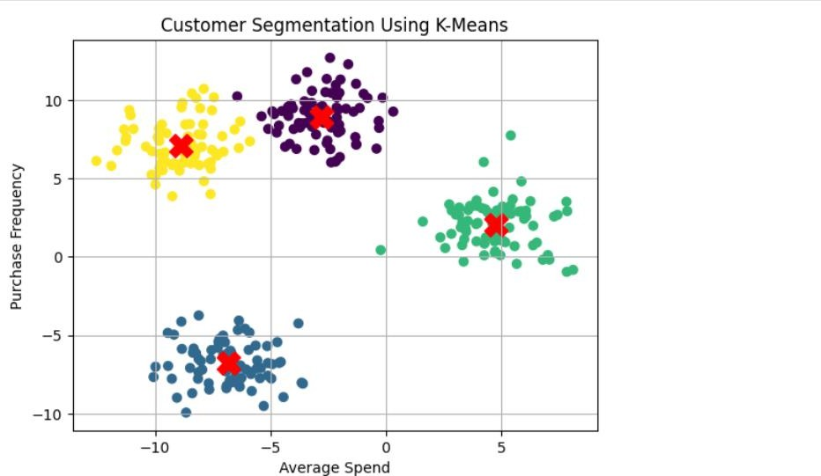

Case Study 2: Genomic Data Compression Using PCA
A bioinformatics lab is working with high-dimensional gene expression data. Each sample contains thousands of gene expression values. For visualization and classification, they need to reduce the dimensionality without losing essential information.
The team uses Principal Component Analysis (PCA) to reduce the dataset from thousands of features to just 2 or 3 principal components.
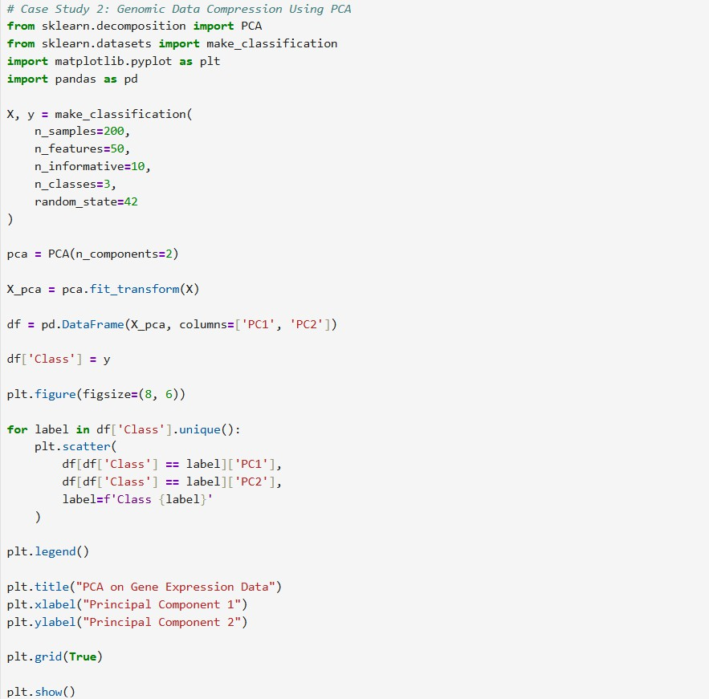

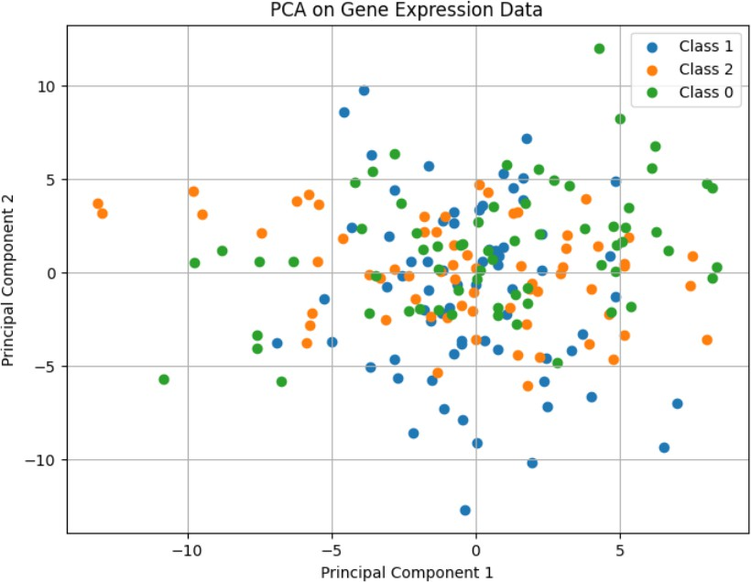

Case Study 3: Handwritten Digit Recognition
A logistics company wants to automatically process zip codes written on packages. This requires recognizing handwritten digits in real time. They decide to use an Artificial Neural Network (ANN) to classify images of handwritten digits.
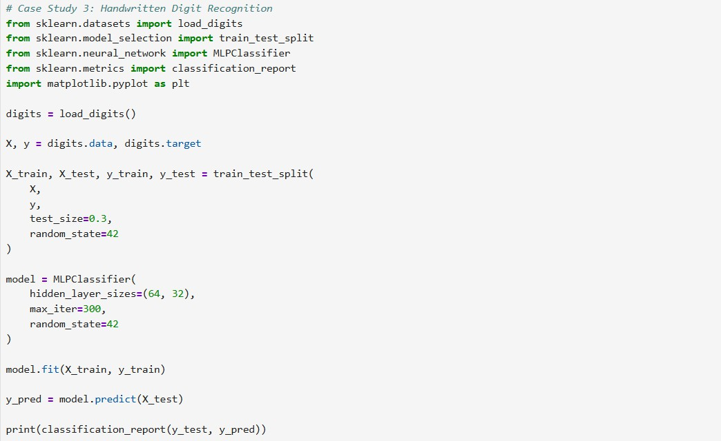
They use the MNIST dataset to train a basic neural network using MLPClassifier.

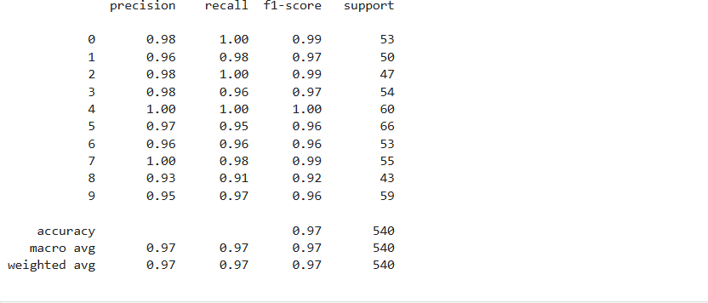
Case Study 1: Dynamic Pricing Optimization in Airline Industry Technique: Cluster Analysis

Scenario: An international airline wants to personalize ticket pricing using customer behavior data, moving beyond traditional booking class segmentation.
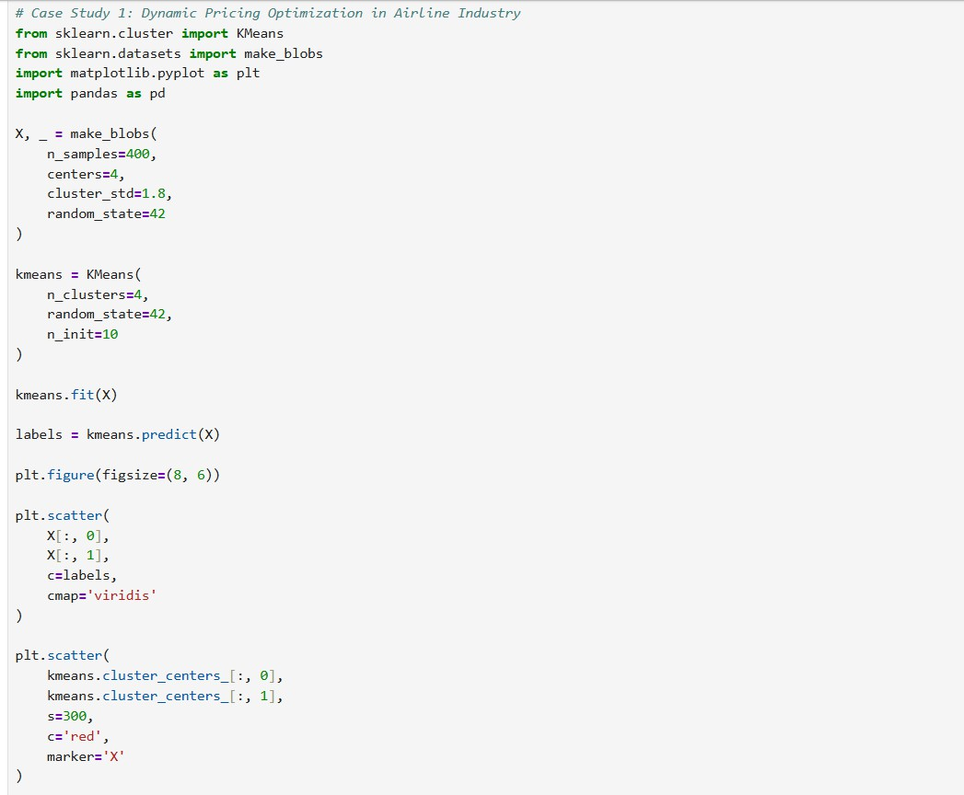

Objective: Identify hidden passenger segments to optimize dynamic pricing and increase revenue efficiency.

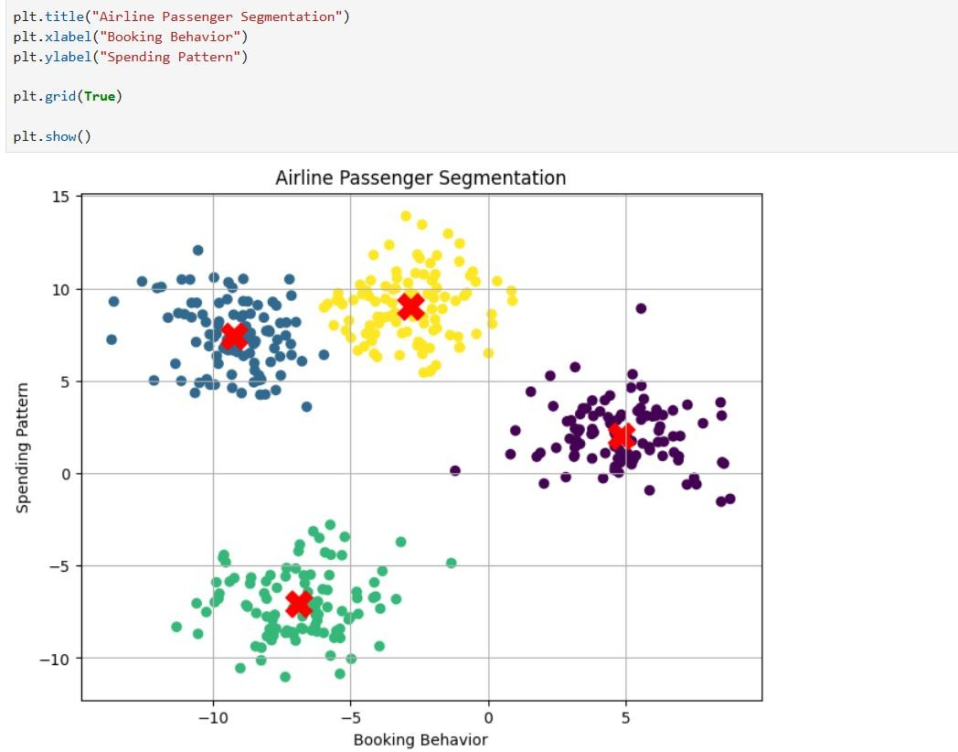

Case Study 2: Early Diagnosis of Parkinson’s Disease Technique: PCA + Artificial Neural Networks

Scenario: A healthcare research institute uses voice recordings to detect early signs of Parkinson’s, dealing with hundreds of acoustic features per patient.

Objective: Reduce data dimensionality and train an accurate neural network classifier for early, non-invasive diagnosis.
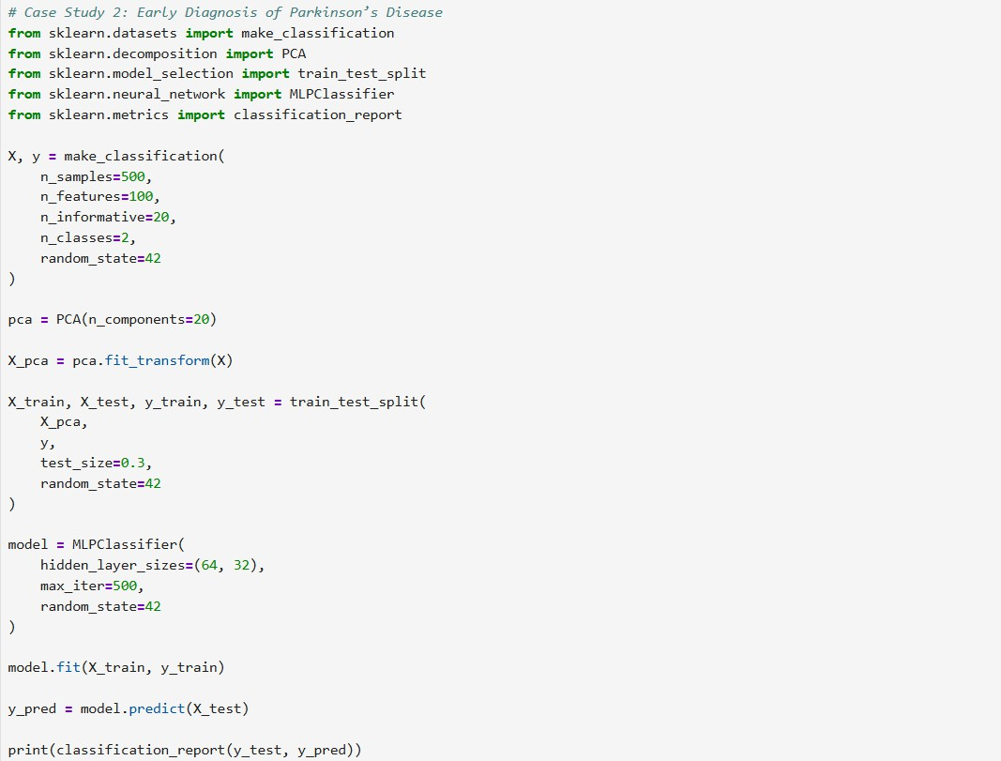

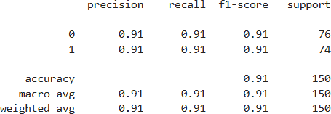

Case Study 3: Credit Card Fraud Detection at Scale Technique: ANN + PCA

Scenario: A financial company processes millions of credit card transactions and wants to detect fraud patterns hidden in complex, high-dimensional data.

Objective: Reduce noise and redundant features using PCA, and apply ANN to classify transactions as fraudulent or genuine in real time.
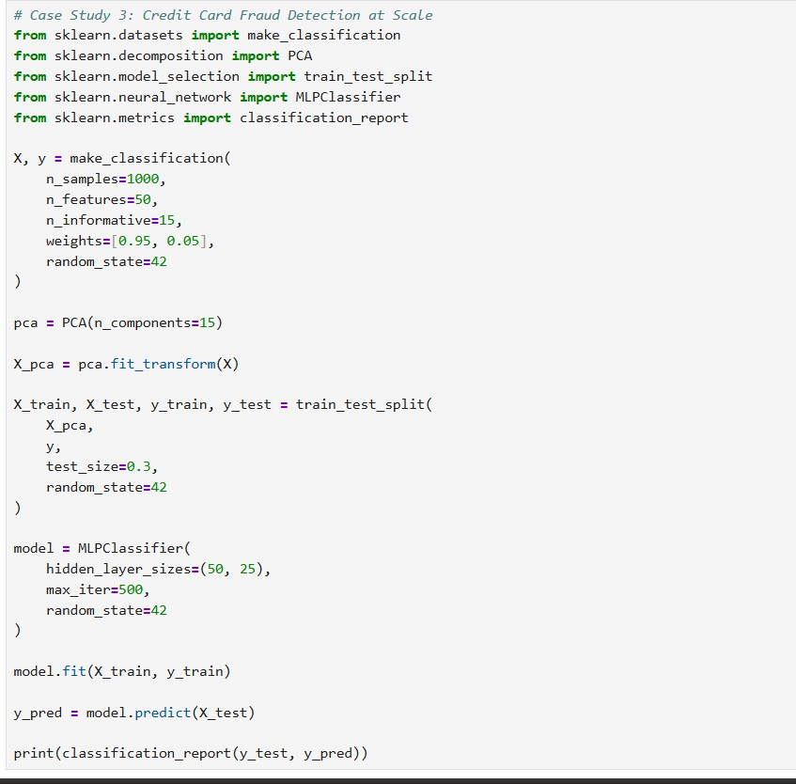
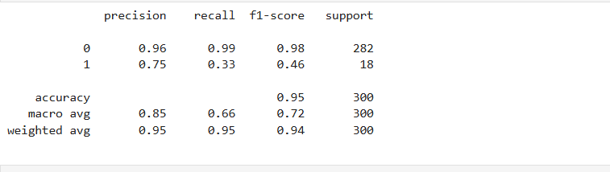

Case Study 4: Consumer Trend Mapping in Retail Chain Technique: Cluster Analysis + PCA

Scenario: A national retail chain wants to understand evolving customer preferences across regions using transaction data, product choices, and seasonal trends.

Objective: Uncover underlying patterns and segment customers based on regional behaviors and product affinity using clustering on PCA-reduced data.
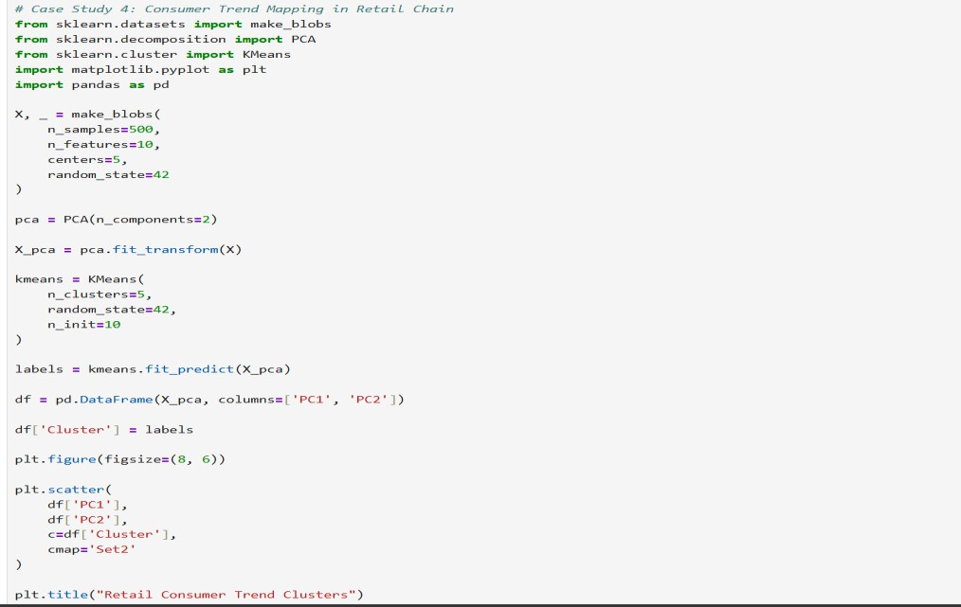
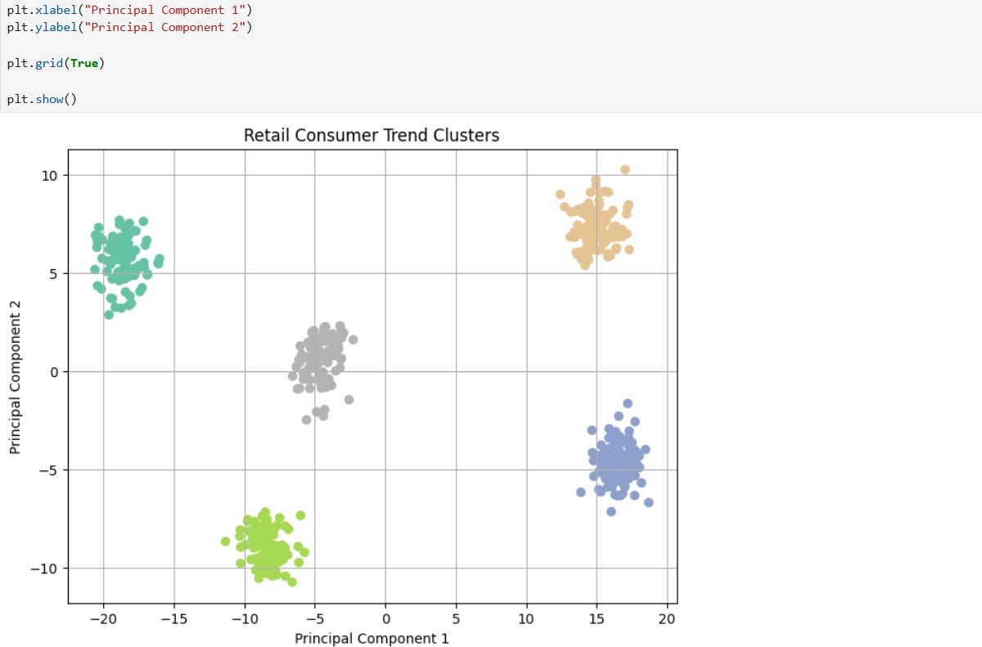

Case Study 5: Quality Control in Smart Manufacturing Technique: ANN

Scenario: An electronics manufacturer uses real-time sensor data from assembly lines to detect potential defects. Data includes vibration, temperature, voltage, and acoustic signals.

Objective: Train an ANN model to classify products into “pass” or “defect” categories with high accuracy to enable automated quality assurance.
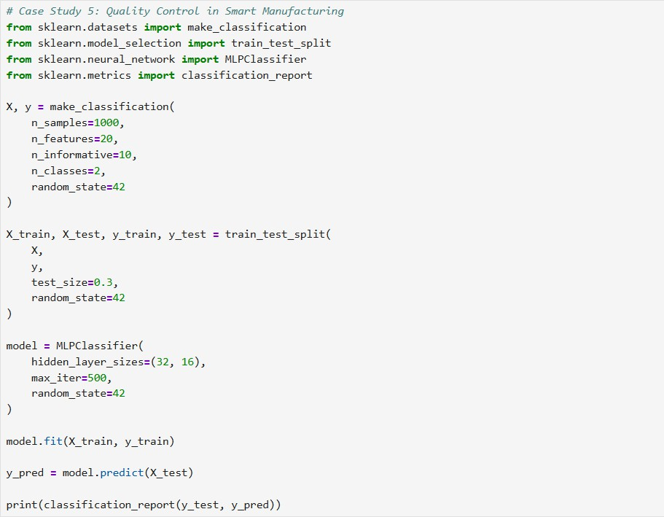
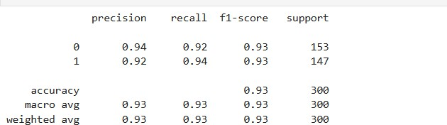

https://github.com/ejazkhan-02/Lab-Task-13-K-Means-Clustering-PCA-and-Artificial-Neural-Networks.git

